PRACTICAL :- 3

**AIM: Installation and Configuration of Hosted Based Hypervisor (VMware / Oracle virtual BOX).**

# What is Hypervisor?

A hypervisor is a form of virtualization software used in Cloud hosting to divide and allocate the resources on various pieces of hardware. The program which provides partitioning, isolation, or abstraction is called a virtualization hypervisor. The hypervisor is a hardware virtualization technique that allows multiple guest operating systems (OS) to run on a single host system at the same time. A hypervisor is sometimes also called a virtual machine manager(VMM).

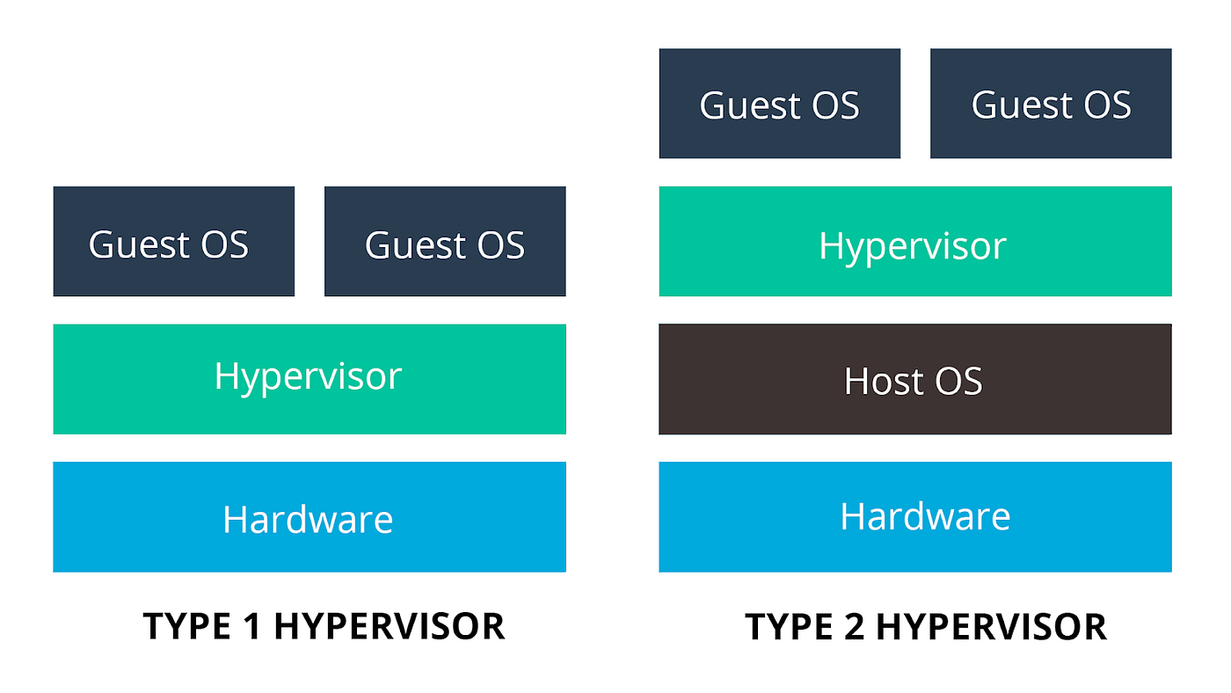

Figure 3.1: Types of Hypervisor

TYPE-1 Hypervisor:

The hypervisor runs directly on the underlying host system. It is also known as a “Native Hypervisor” or “Bare metal hypervisor”. It does not require any base server operating system. It has direct access to hardware resources. Examples of Type 1 hypervisors include VMware ESXi, Citrix XenServer, and Microsoft Hyper-V hypervisor.

Pros & Cons of Type-1 Hypervisor:

Pros: Such kinds of hypervisors are very efficient because they have direct access to the physical hardware resources(like Cpu, Memory, Network, and Physical storage). This causes the empowerment of the security because there is nothing any kind of the third party resource so that attacker couldn’t compromise with anything.

Cons: One problem with Type-1 hypervisors is that they usually need a dedicated separate machine to perform their operation and to instruct different VMs and control the host hardware resources.

TYPE-2 Hypervisor:

A Host operating system runs on the underlying host system. It is also known as ‘Hosted Hypervisor”. Such kind of hypervisors doesn’t run directly over the underlying hardware rather they run as an application in a Host system(physical machine). Basically, the software is installed on an operating system. Hypervisor asks the operating system to make hardware calls. An example of a Type 2 hypervisor includes VMware Player or Parallels Desktop. Hosted hypervisors are often found on endpoints like PCs. The type-2 hypervisor is very useful for engineers, and security analysts (for checking malware, or malicious source code and newly developed applications).

Pros & Cons of Type-2 Hypervisor:

Pros: Such kind of hypervisors allows quick and easy access to a guest Operating System alongside the host machine running. These hypervisors usually come with additional useful features for guest machines. Such tools enhance the coordination between the host machine and the guest machine.

Cons: Here there is no direct access to the physical hardware resources so the efficiency of these hypervisors lags in performance as compared to the type-1 hypervisors, and potential security risks are also there an attacker can compromise the security weakness if there is access to the host operating system so he can also access the guest operating system.

**What is VirtualBox?**

Oracle VM VirtualBox is a cross-platform virtualization application developed by the Oracle Corporation. It allows users to install operating systems on virtual hard disks such as Windows, macOS, Solaris and Linux.

As an example, you can run Windows and Linux on your Mac, run Windows server on your Linux server, or run Linux on your Windows PC while running your other existing applications.

Disk space and memory are the only problems that you'll face when installing multiple virtual machines.

**Why You’ll Need It**

* Oracle’s Virtual Box is easy to install and use
* It's free
* You can run and experience any operating system safely
* If you’re a developer, Virtual Box can be used as a tool for safely testing your own development projects in multiple OS environments
* It can run everywhere from small embedded systems to laptops
* It's good for testing and disaster recovery as it can be easily copied, backed-up, and transported between hosts

**VirtualBox Installation**

VirtualBox can be downloaded here: [VirtualBox Downloads](https://www.virtualbox.org/wiki/Downloads)

**Why Ubuntu?**

* It's free
* Easy customization: The GNOME desktop environment helps you customize easily
* It's secure
* Ubuntu is open-source
* Friendly and supportive community
* Low system requirements
* According to [FOSSBYTES](https://fossbytes.com/best-linux-distros-for-programming-developers/), Ubuntu is the second best Linux distro for programming and developers [2019 Edition]
* It's beginner friendly

**Setup for Ubuntu**

First, open VirtualBox, then click "New" to create a virtual machine.

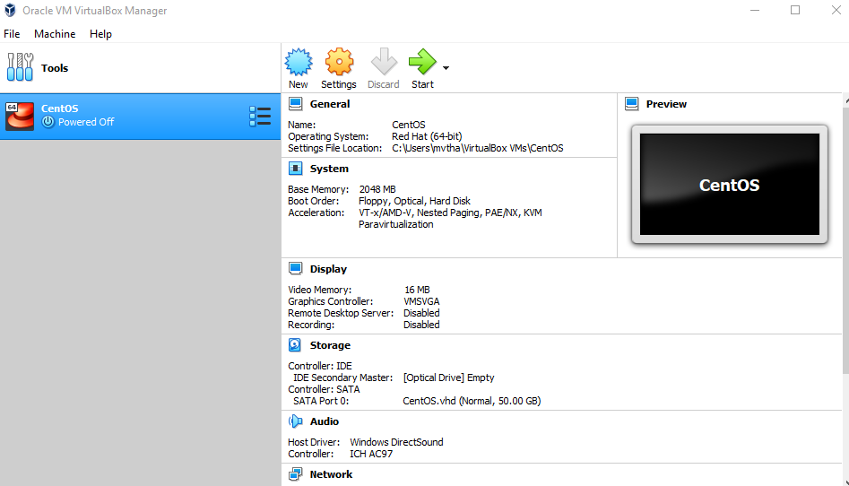

Enter "Ubuntu" as the name, select "Linux" as the type, and select Ubuntu (64-bit) as the version.

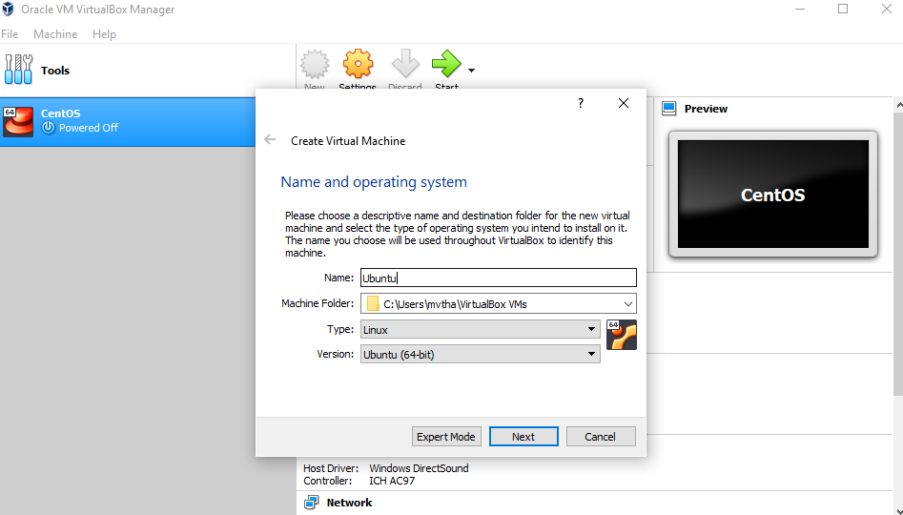

**NOTE**: Select any amount of memory you wish, but don't add more than 50 percent of your total RAM.

Check the "Create a virtual hard disk now" option so we can later define our Ubuntu OS virtual hard disk size.

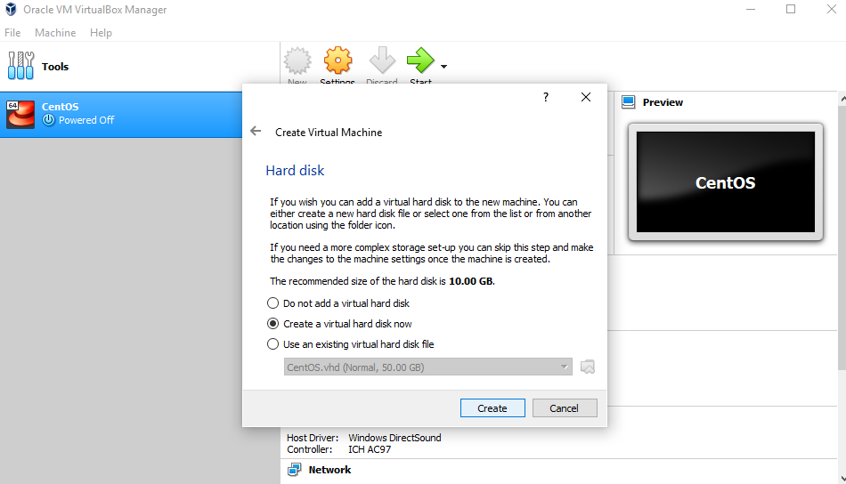

Now, we want to select "VHD (Virtual Hard Disk)".

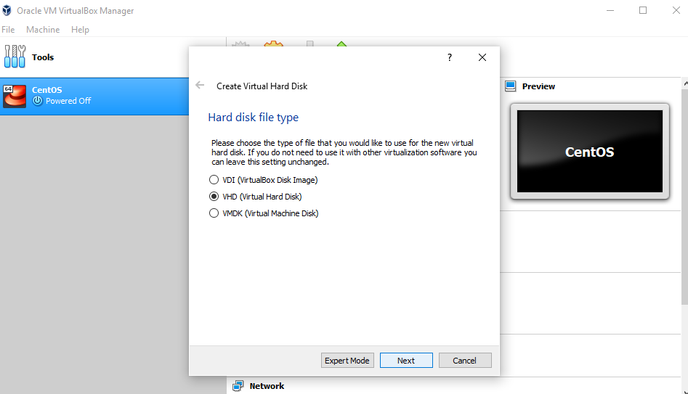

Next, we'll dynamically allocate storage on our physical hard disk.

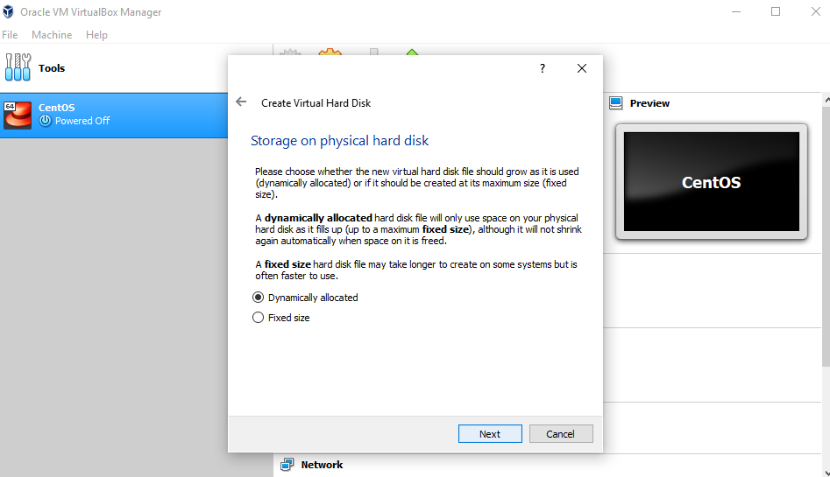

We want to specify our Ubuntu OS's size. The recommended size is 10 GB, but you can increase the size if you wish.

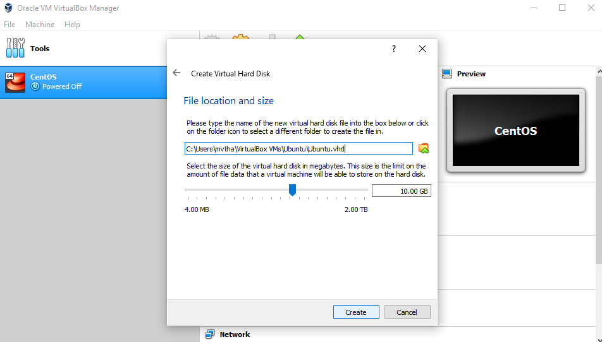

After creating a virtual hard disk, you'll see Ubuntu in your dashboard.

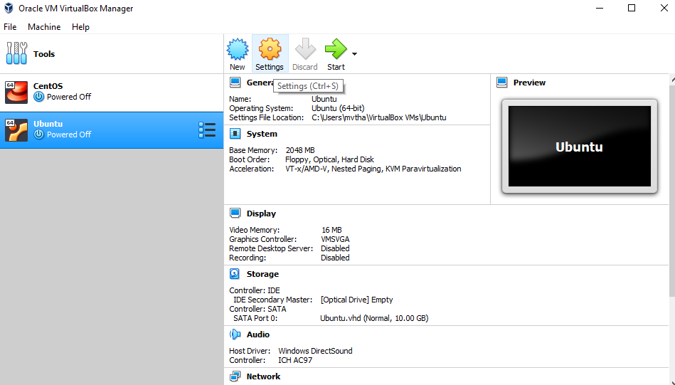

Now, we have to set up the Ubuntu disk image file (.iso).

The Ubuntu disk image file can be downloaded here: [Ubuntu OS download](https://ubuntu.com/#download)

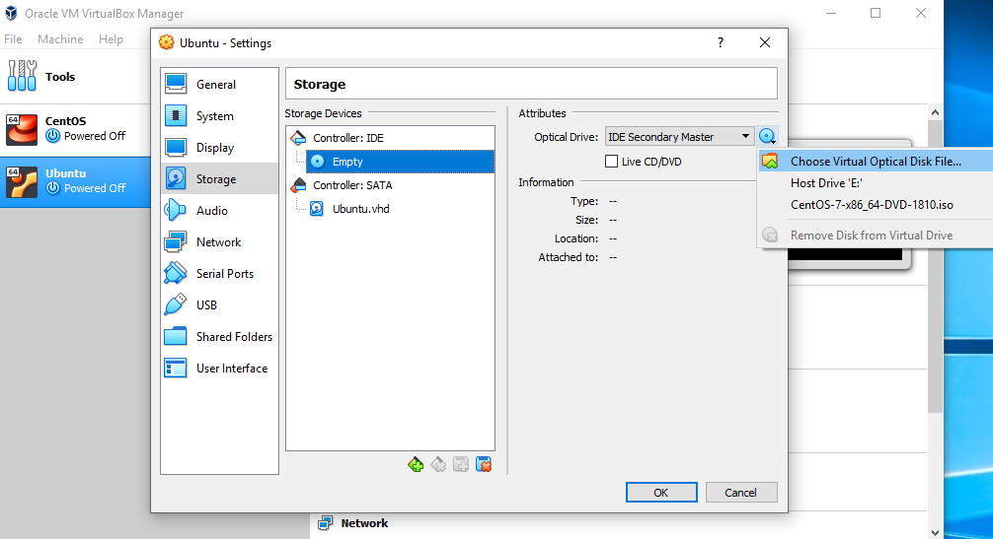

To set up the Ubuntu disk image file, go to settings and follow these steps:

1. Click "Storage"
2. In storage devices, click "Empty"
3. In attributes, click the disk image and "Choose Virtual Optical Disk File"
4. Select the Ubuntu disk image file and open it

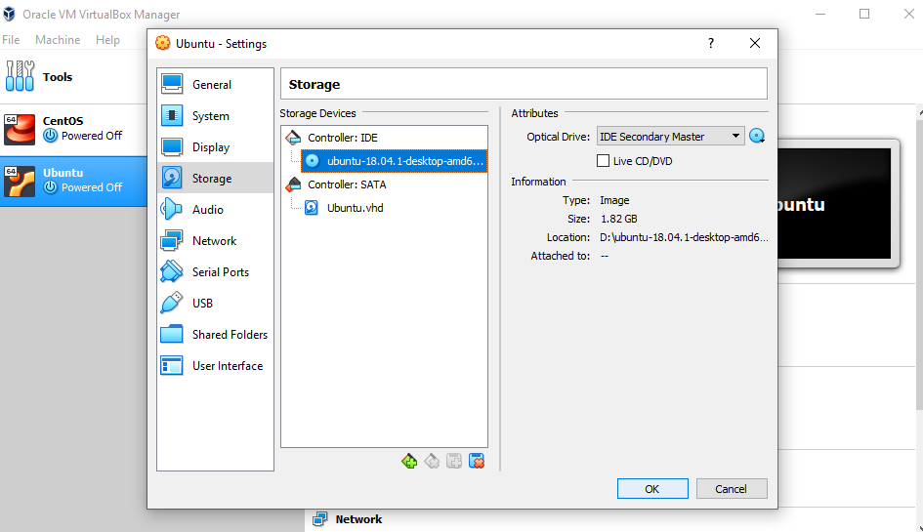

Click OK.

Your Ubuntu OS is ready to install in VirtualBox. Let's start!

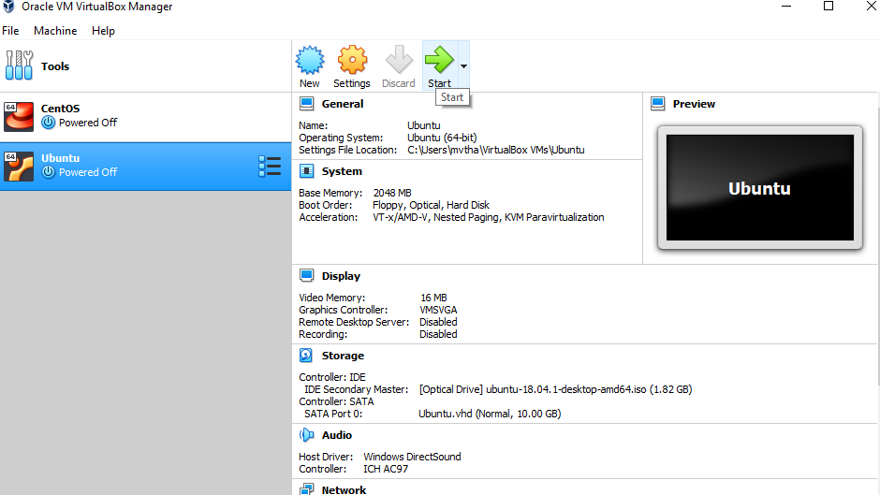

**NOTE:**Ubuntu VirtualBox installation and actual OS installation steps may vary. This guide helps you to install Ubuntu in VirtualBox only.

**Let's install Ubuntu!**

Click Install Ubuntu.

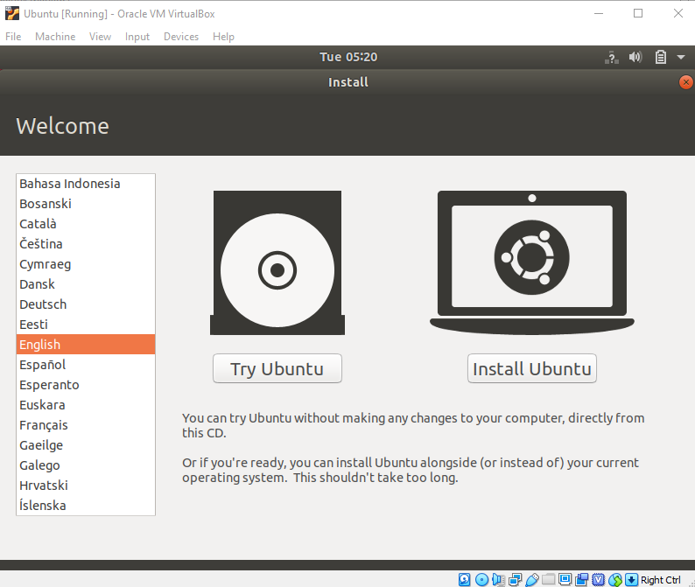

Select your keyboard layout.

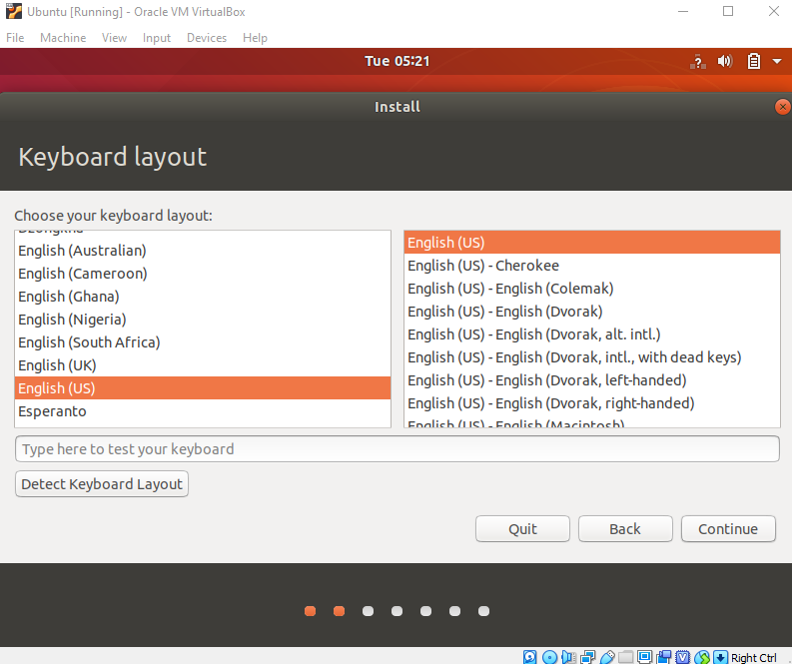

In the "Updates and other software" section, check "Normal installation" and continue.

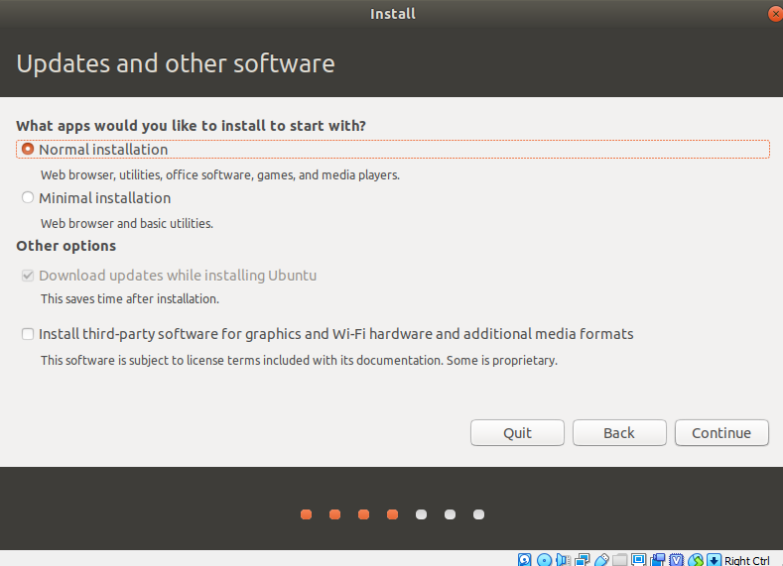

In "Installation type", check "Erase disk and install Ubuntu".

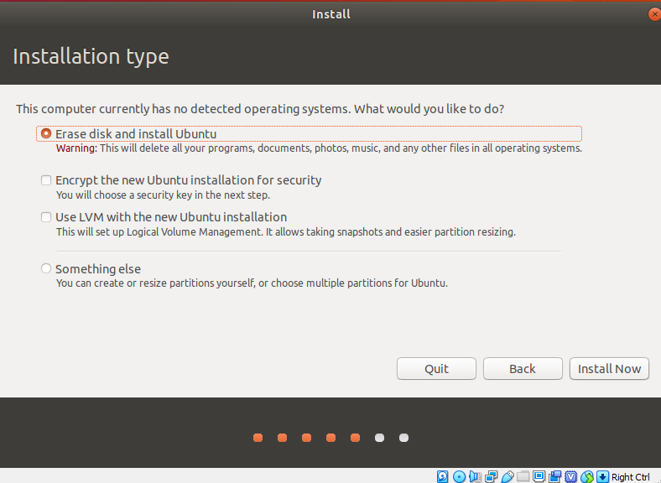

Click "Continue".

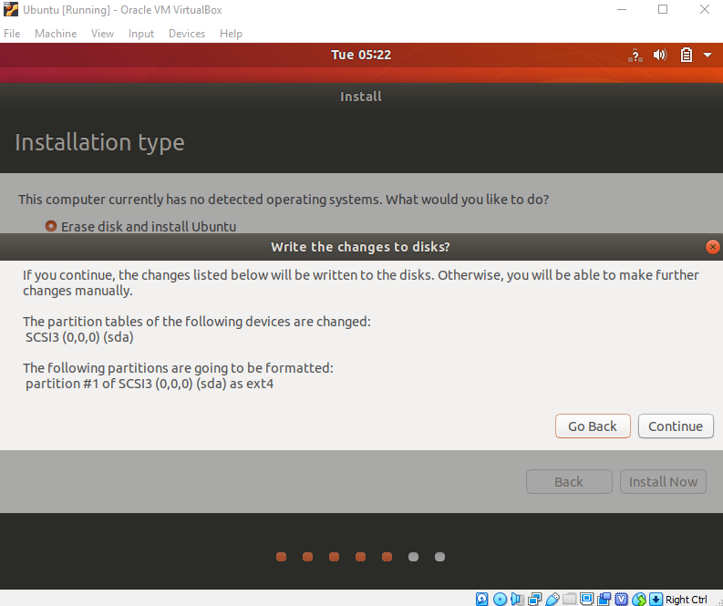

Choose your current location.

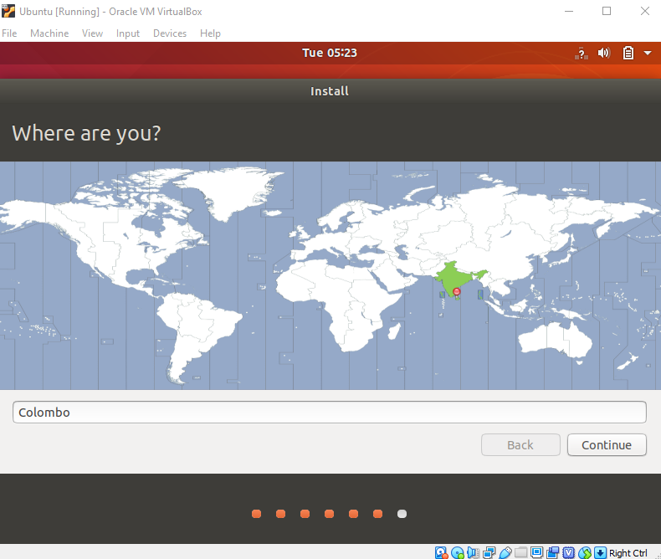

Now, set up your profile.

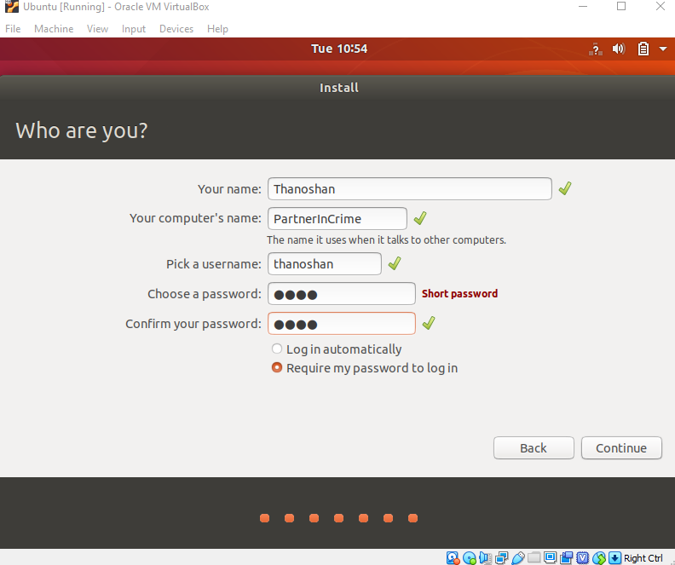

You'll see Ubuntu installing.

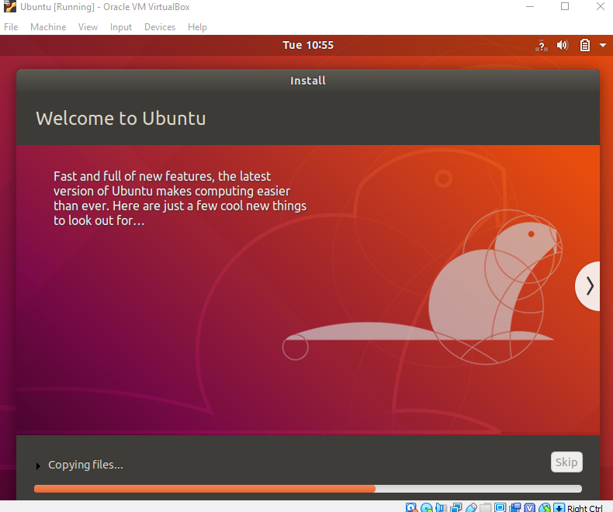

After the installation, restart it.

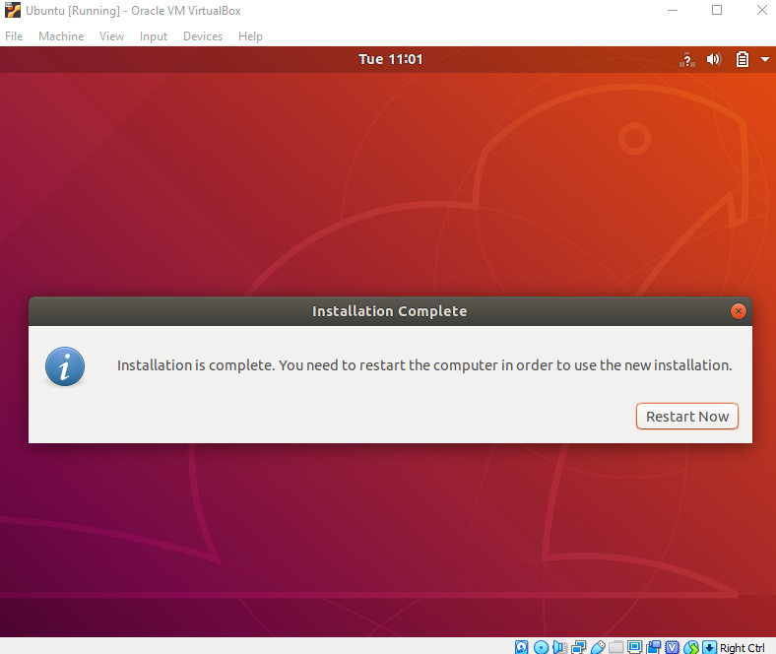

After logging in, you'll see the Ubuntu desktop.

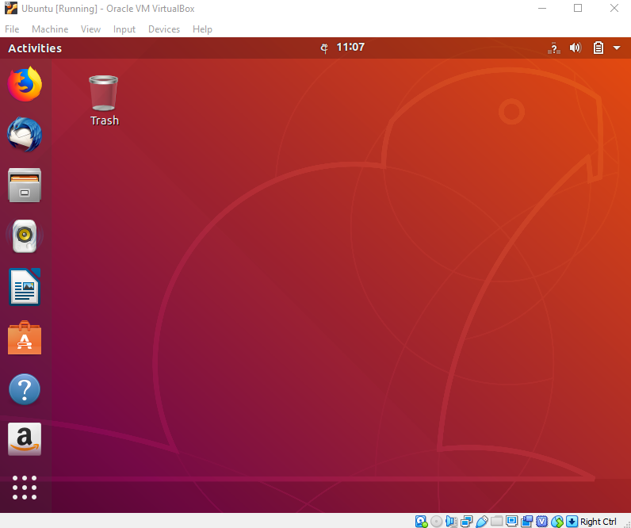

We have successfully installed Ubuntu in VirtualBox. It's ready to use for your future development projects.

**Let's verify the installation.**

Open your terminal (Press Ctrl+Alt+T) and type in the commands below and check if they work.

1. pwd: This will print the current working directory
2. ls: This will list all items in your current directory

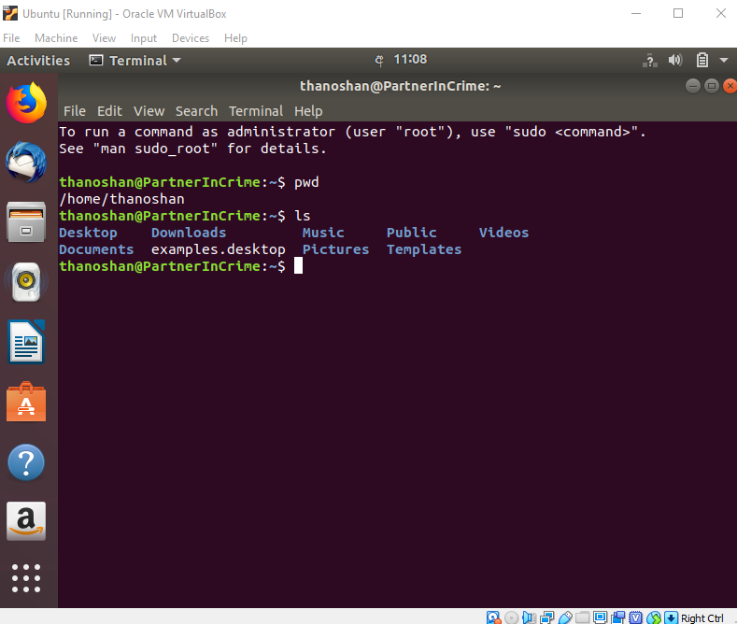

After checking those, power off your machine by using the following command.

poweroff

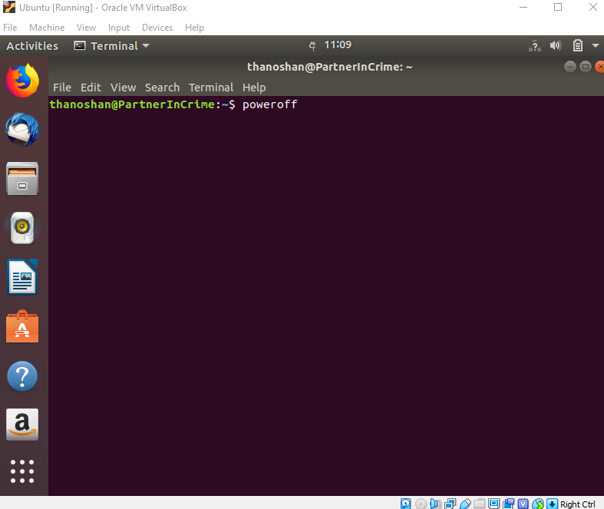

**Conclusion**

VirtualBox is free and is a great tool for running multiple operating systems on a single OS. Ubuntu has many benefits. If you're a beginner to Linux, I would recommend you use Ubuntu as it's beginner friendly.

